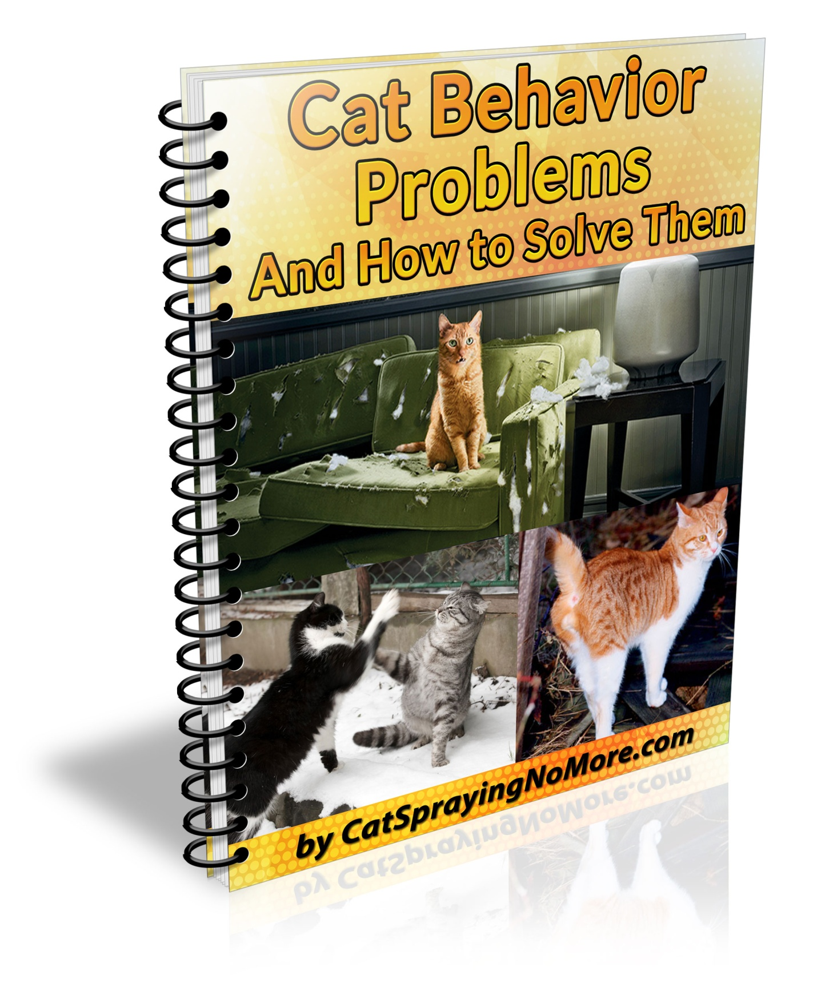
Copyright ©2018 by CatSprayingNoMore.com
You are being granted Giveaway Rights to distribute this eBook for FREE as long as it’s not altered in any way.

We hope you enjoy reading this eBook. If you want to learn more on how to Stop Cats from Spraying by using an easy to follow system click on the link below:

www.CatSprayingNoMore.com

Cat Behavior Problems &
How to Solve Them
Second Edition

Table of Contents
Contents
Caring for your Cat 5
Teaching and Training your Cat 5
Cat “Misbehavior” is Natural Behavior 6
Keeping your Cat Occupied 7
Understanding the Feline Mind 8
Training Requires Consistency 8
Dealing with Biting 9
Dealing with “Gifts” of Dead Animals 9
Ways to Curb Cat Scratching 10
Cats Scratch to Mark Territory 11
Stop Scratching and Reduce Damage 12
Choosing the Right Scratching Post 12
Strategic Scratching Posts Location 13
Cats and Litter Boxes 13
Easy Litter Box Tips 14
The Number of Litter Boxes is Important 15
Breaking Bad Habits 15
Ridding your Cat of Fleas 16
How to Prevent Fleas 16
Signs of an Infestation 17
Dealing with Flea Infestations 17
Diet Supplements to Repel Fleas 17
Disinfecting Floors and Surfaces 18
Living in Harmony with your Pet 18

Caring for your Cat
Owning a cat can bring you a lot of joy, but having a cat in your home can be a challenge. Living in harmony can be difficult when faced with some of the more common issues a cat can bring with it. Your cat may cause frustration by eliminating around the house, refusing to use a litter box. Your furry friend may decide your prized furniture would make a great place to sharpen its claws. Even worse, your pet may bring along “guests” of their own – infesting your house with fleas. Dealing with these parasites can be a chore. You may need to deal with many generations of these insects, as their eggs contaminate your house.
This book will help you with some of the most common problems that come with living with cats. You will discover how to effectively correct their behavior. We’ll provide simple tricks to teach you how to prevent your cat scratching up your furniture. You will also learn how to train your cat to use a litter box, or help you deal with a flea infestation. These techniques will make having a feline around the house a positive experience.

Teaching and Training your Cat
Cats have a reputation for being stubborn and hard to train. While not impossible, training a cat how you want it to behave in your house can be a challenge. Many people try to train a cat by punishing it, but that rarely works. It may even traumatize the cat, making it anxious and stressed. That can result in even worse behavior. To get a cat to behave how you wish, you must understand how it thinks.
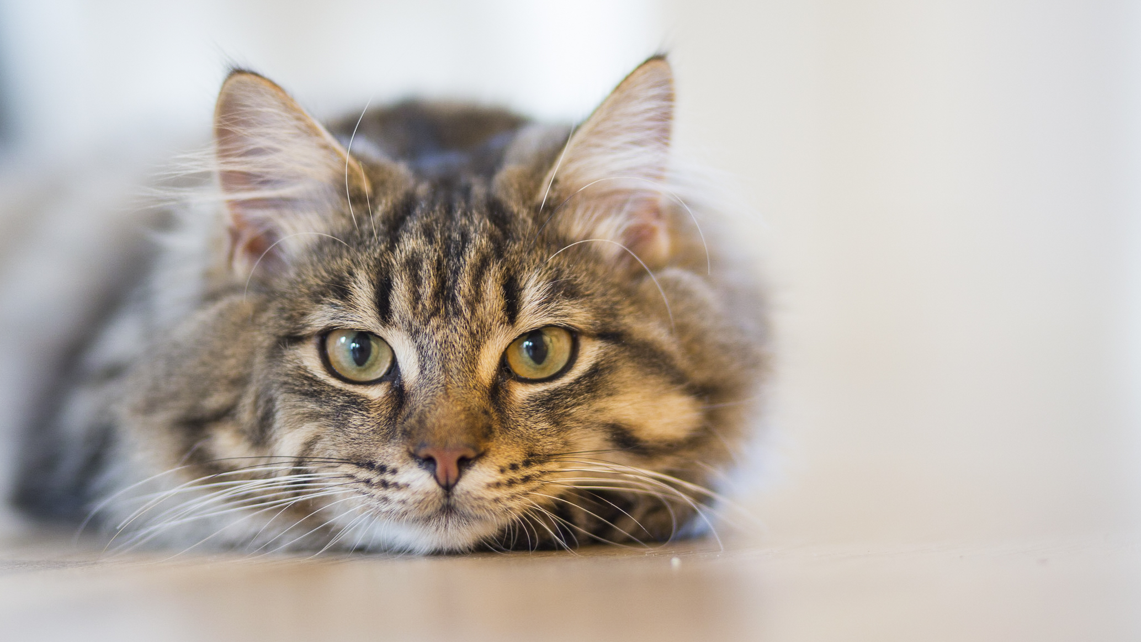

Cat “Misbehavior” is Natural Behavior
In the wild, cats are hunters. Every cat likes to climb and chase things. So if your cat knocks over an expensive vase while doing so, it isn’t because the cat is “naughty” - it’s having fun! Cats love to play, and you can’t expect that they stop. It’s part of what makes them what they are, and part of why we humans love them. The key is not to stop having fun, but to show them how to have fun in ways that don’t cause damage. A cat that doesn’t play may have a lot of excess energy. That energy might find an outlet at the expense of your furniture or crockery.

The same principle applies to a cat sharpening its claws
A cat must continually sharpen its claws. In the wild, those claws enable it to hunt and eat. They allow a cat to climb, both to find prey and to escape danger. Those claws enable it to defend itself. They also prevent it from losing its grip when walking along some high perch. In nature, keeping its claws sharp is a matter of life and death to a cat. You are going to find it difficult to convince your cat that sharpening its claws is “unimportant”. You need to provide it with acceptable alternatives to this behavior. We’ll go into this in more detail a little later in this book.

Keeping your Cat Occupied
You must always remember that your cat is a living creature with needs and feelings. If it has nothing to do but lounge around the house all day, it is going to get bored. A bored cat can be a source of major trouble around the house. There are some simple, inexpensive things you can do to keep your cat occupied. A great distraction is to provide a climbing tower. This can consist of a vertical beam with rough cord wrapped around it leading to a perch at the top. This will not only occupy your cat, but also ensure that it gets enough exercise. Scattering a few scratching posts around the house can also be a nice distraction for your pet. Something as simple as a bundle of cut up paper on a string, whipped around by hand, can prove deeply interesting to your cat. Spending some time every day playing with your cat is also very beneficial for the animal.
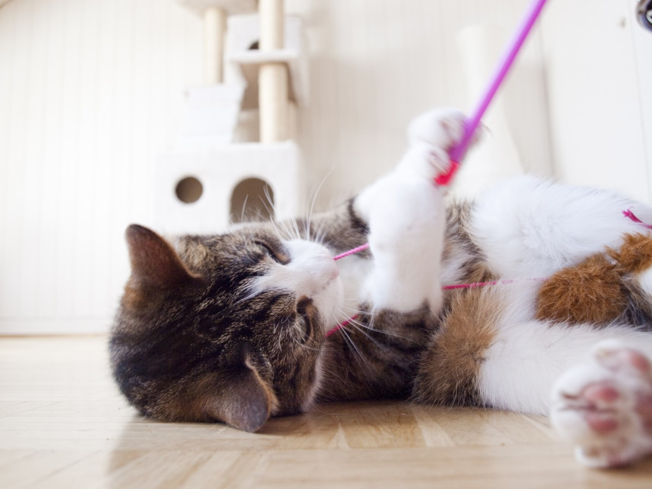

Understanding the Feline Mind
As human beings, we do not like being shouted at, struck, or locked in a room. We hate having something we like taken away from us. Cats share all those traits with us!, but without the capability to reason things out. When you shout at a cat, it may feel that it has attracted your interest. The shouting could be part of some game! This could work to reinforce the very behavior you are trying to discourage. If you become aggressive enough, your pet can become afraid of you and may simply leave. That is hardly the goal you have in mind.
The way to get a cat to behave as you desire is to reward good behavior with positive experiences. Praise, petting, playing, and spending time with the animal are all positive reinforcements. When a cat does something wrong, you can withhold these activities from the animal for a short time. This works much better than using aggression and negativity.
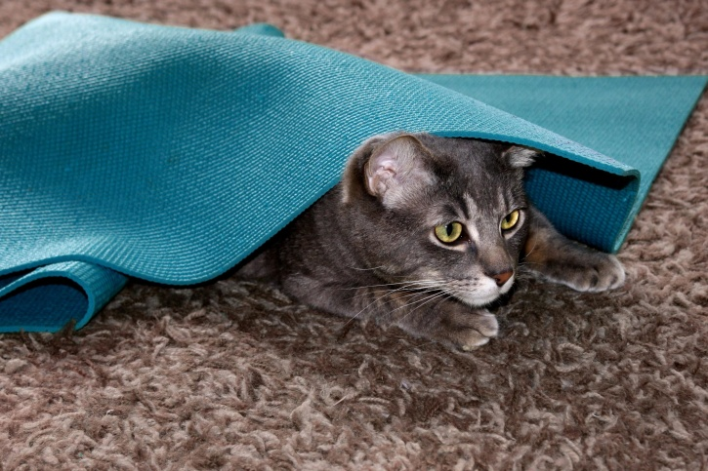

Training Requires Consistency
The training responses you are using with your cat require consistency. There is no point in reacting one way during one occurrence of the behavior and differently the next time. This can be extremely confusing for your cat. It will not be able to understand whether you want it to behave one way or another.
The best positive responses are petting, talking to your cat, and playing with it. These are perfect ways to reinforce good behavior. Your cat will be a much happier animal as well. When your cat does something wrong, you can ignore it completely. Refuse to react to it, talk to it, or play with it, for a little while. This will let the animal know that it has done something wrong, and it will avoid that behavior in future.
By using a combination of positive and negative responses, you will reinforce good behavior. You will also make it very clear that bad behavior gets no rewards. The thing to remember is that for this sort of training program to succeed, you must stay consistent at all times.

Dealing with Biting
A cat has powerful predatory instincts. They will attack anything that moves like their normal prey. You should avoid rapidly moving your hands around in front of its face. Never encourage a cat to attack your hands, especially when it is young. That is training your cat to be aggressive, treating biting and clawing as “play”.
If your cat has gotten into the habit of biting you, you will need to break it of this habit. The first thing to do is to stop bringing your hands within reach of the animal. You need to break your own habit first! When you play with your cat, use a toy, a stick, or a piece of string instead of your hands. If your cat does bite you, say “OUCH” loudly, walk away and ignore it for the next fifteen minutes or so.
Do this every time it bites you, and it will realize that it is not meant to do that. Reinforce this with good treatment at other times. If you get through a playing session biting issues, reward your cat with kind words and attention.

Dealing with “Gifts” of Dead Animals
It can be unpleasant to find a dead animal in the middle of a room, but this behavior shows your cat’s affection for you. Perhaps they want to share their “success” with you. They are trying to contribute to the food resources of the family. Your cat does not realize that the family will not see the dead animals it brings home as “gifts”.
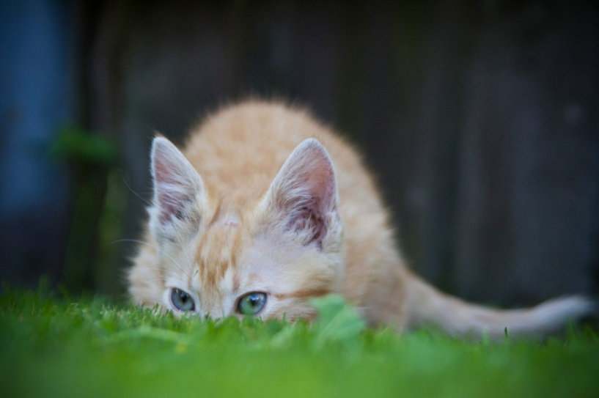
Keep that in mind as you determine how to correct this behavior. This is unselfish, positive behavior to your cat. You must be careful to avoid any negative feedback or punishment that could stress your pet.
What should you do to discourage your cat’s thoughtfulness? There are a couple of good options. One of the best approaches to deter gift-giving is rein in your cat’s wanderings. Keep them indoors, load them up with puzzle toys to play with on their own or get toys that you can dangle and drag for their pleasure. If your cat is to stay “roaming” outside, put a loud bell on his collar to give their victims a fighting chance. It does not work consistently, but it may reduce your cat's kill rate. If your cat wears a collar, make sure it is a breakaway type; it should have a clasp that will release if the collar gets hooked on an object.
If your housemate still brings you prey, ignore it as best you can, do not praise them. Offer them a catnip-stuffed toy in return and dispose of the “gift” while they are not paying attention. With luck and persistence, they may begin to bring you the catnip toys instead.

We hope you are enjoying reading this eBook. If you want to learn more on how to Stop Cats from Spraying by using an easy to follow system click on the link below:
www.CatSprayingNoMore.com

Ways to Curb Cat Scratching
Why does your cat love to scratch things? Cats have an instinct to sharpen their claws regularly, leading to some scratching. While that may help explain their tendency to rip apart books, boots and furniture, it is not the main reason. Cat’s paws also contain scent glands. By scratching, a cat is marking its territory.

Cats Scratch to Mark Territory
The presence of multiple cats in a home may increase scratching behavior. But a cat will scratch regardless of there being other cats around. It is a natural instinct that has been around since there were cats, and they’re not going to let go of it lightly. Scratching is also a form of stretching and mild exercise for your cat and feels pleasant. You can reduce the occurrence of scratching behavior through patience, creativity and consistency.
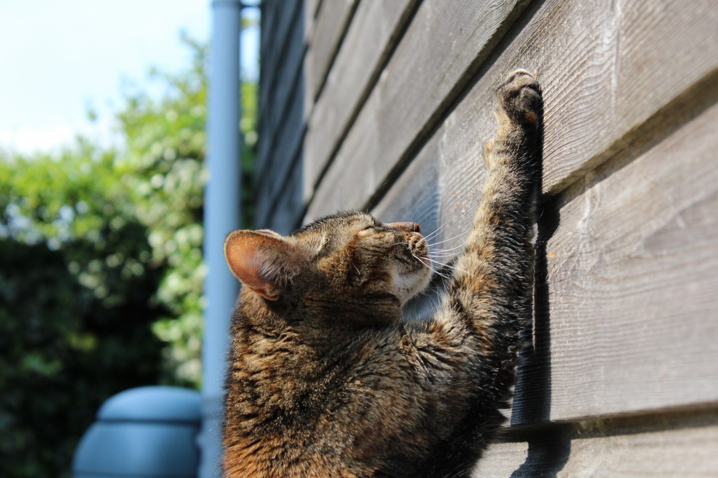

Stop Scratching and Reduce Damage
You can never eliminate a cat’s need and desire to scratch. It is only by working with your cat’s basic instincts that you can address issues of inappropriate scratching around the house. Working against their instincts will almost certainly lead to failure.
You can minimize damage with some simple steps. The first and easiest method is to regularly clip your cat’s nails. Doing this makes the feline feel more comfortable. It also reduces the damage caused by scratching furniture or drapery. You can also use tape or different texture treatments on surfaces susceptible to scratching. Cats have extremely sensitive paws, so changing the “paw-feel” of a surface may be enough to get it to stop seeing it as a target.

Choosing the Right Scratching Post
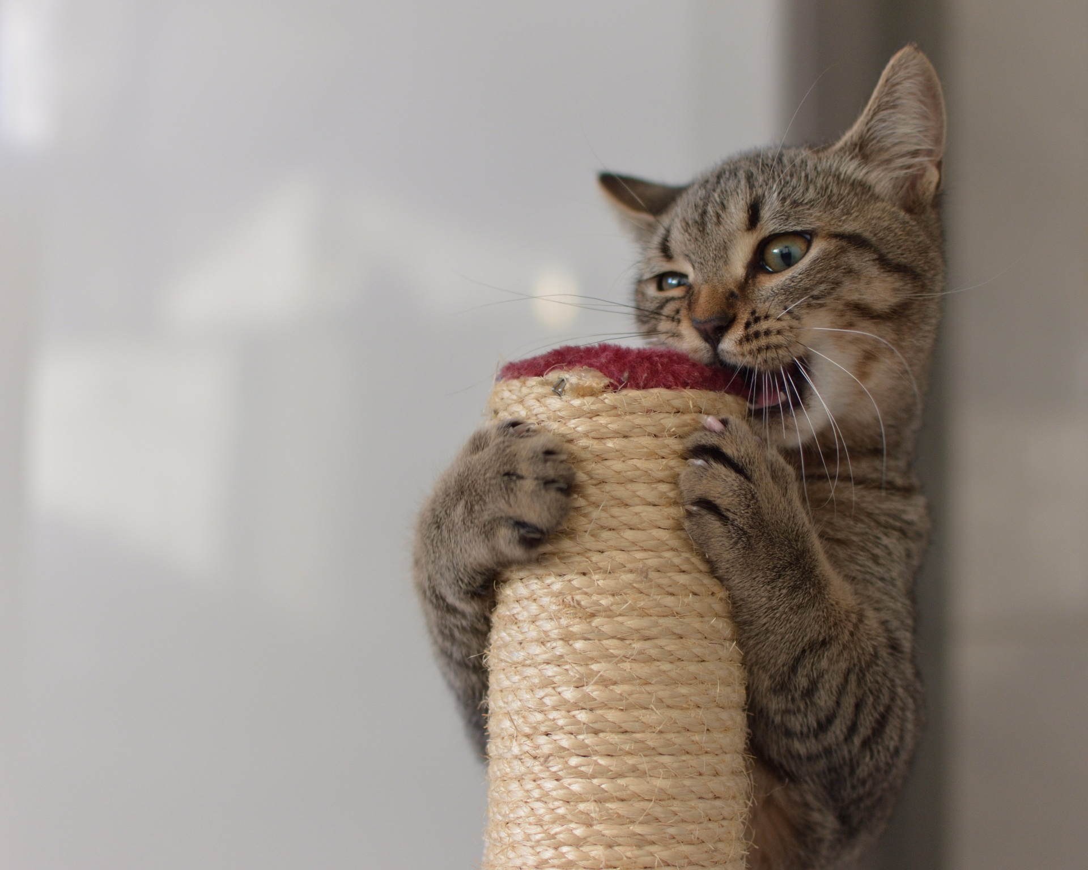Domestic cats get their instinct for scratching from their wild ancestors. Those creatures sharpened their claws on the bark of trees. Big cats like lions and tigers still do this. Your cat is very much a miniature tiger when it comes to this behavior. If you provide it with the right scratching post its instincts will take over. Your cat will prefer to scratch the post, forgetting all about your furniture.

What sort of scratching post will work best?
The type of scratching material a cat prefers is can vary by the cat. Different cats will respond differently to different materials. You may need to experiment a little before you find a scratching post that your cat prefers. There are many materials used to cover scratching posts. All of them attempt to mimic what a “wild” cat would find in their environment. Materials like carpet, hemp, sisal or cardboard are common. Posts wrapped in rough rope also work quite well. Cats prefer a sturdy material that they can feel “shredding” as they scratch it. You will have to see which material works best for your cat.

Strategic Scratching Posts Location
Placing scratching posts according to your interior design ideas may not result in your desired outcome. Your cat has areas that it thinks need a good scratch, and it may make its own efforts at interior decoration. The result is a ruined couch or drapery, while the scratching post rests unused in a discreet corner.
A scratching post must be placed in a position that makes it a viable alternative to furniture. Putting it in a location where your cat does not feel comfortable, like a cellar or basement, is useless. Your cat is never going to make a “special” trip there to scratch it. It may not even remember that it is there.
A scratching post must also be well anchored. A cat is a very strong animal for its size If it can knock over a scratching post it may quickly lose interest in it. If the scratching post falls on the cat, the loss of interest is likely to be permanent.

What locations work best?
If your cat consistently scratches an item of furniture, place a scratching post right next to that item. That will help distract your cat from the furniture. Placing the post in a prominent location in the room can also be a good strategy. You want it where the cat is likely to see it as soon as it enters the room.

We hope you are enjoying reading this eBook. If you want to learn more on how to Stop Cats from Spraying by using an easy to follow system click on the link below:
www.CatSprayingNoMore.com

Cats and Litter Boxes
If you have a cat, you will need at least one litter box in your house. It can be extremely frustrating when a cat refuses to use its litter box and instead eliminates in different places around the house. The why’s and where’s of a cat’s litter box preferences can be mysterious. There are a few simple tricks to prevent or rectify a cat’s inappropriate elimination habits.
The first thing that you need to do if your cat exhibits inappropriate elimination behavior is visit your veterinarian. If the cat was using the litter box but has changed behavior, you should act. Your cat may be seriously ill. Eliminating this possibility is the most important step.

Easy Litter Box Tips
The first rule is that the litter box needs to be kept very clean. Cats are quite particular about cleanliness, and will not use a dirty litter box. The litter box must be cleaned out once every day, at the very least. Once a week, the litter box should be thoroughly cleaned with a mild disinfectant.
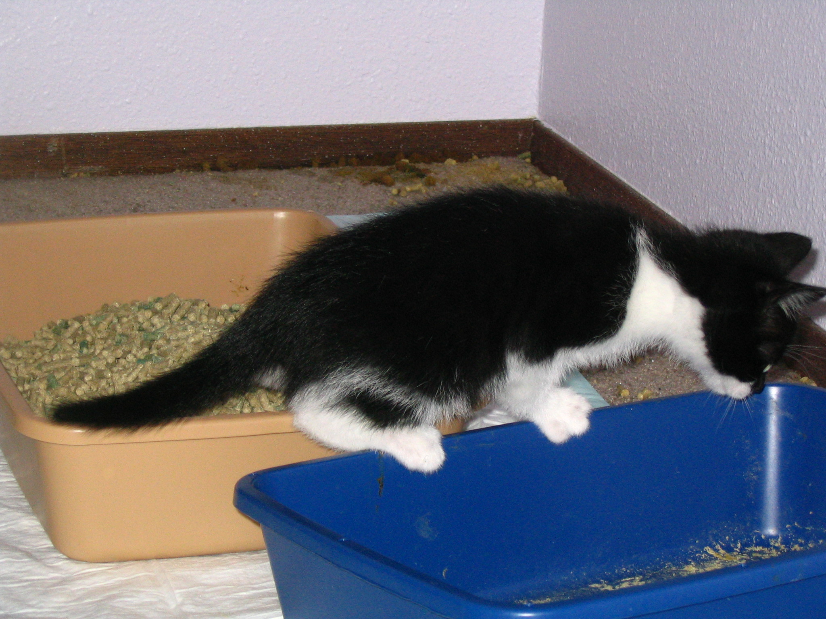

The Number of Litter Boxes is Important
If you have more than one cat, you’ll need a litter box for each of them, as well as an extra one. If you have the right number of properly maintained litter boxes on hand, there is no reason why your cats won’t use them. Litter box placement is also important. Two litter boxes side by side will be seen as a single litter box. It is a good rule to keep litter boxes in separate rooms. Finally, if you live in a house that has more than one story, you’ll need to place at least one litter box on every floor. These are simple rules to follow, but quite important.

Types of litter
The type of litter in a box is as important as its placement. Some cats prefer a grainy texture, while others prefer litter that has clumps. Experiment to see what your cat or cats prefer. Make sure you put enough litter into the box. If it is too little or too much, your cat may refuse to use it. Two inches of litter is a good amount as a rule.

Breaking Bad Habits
If a cat has a habit of eliminating in an inappropriate place in a particular room, they may like that area. If possible, put a litter box in that room. If not, make sure you have provided adequate places in which to eliminate. You may also attempt to make the room inaccessible to the cat if that is practical. Ensure the doors to that room are closed and that no one entering that particular room lets the cat in.

If a cat eliminates anywhere, it is important to clean the area thoroughly
If a room is smelling of cat urine, and you can’t locate where it is, a black light will help you to find it. The urine glows yellowish when exposed to black light in a dark room. To clean the area, use a mild non-ammonia detergent. Ammonia is a component of cat urine and may encourage the cat to return to the area. Once you have cleaned the surface, use an enzyme-based cleaner to completely eliminate the urine. The cat should no longer smell any trace of the urine to be successful.

Ridding your Cat of Fleas
Fleas are the bane of many pet owners. Fleas on cats can be quite difficult to get rid of, as they are both hardy and very agile. They are difficult to kill, nearly impossible to trap. They will easily evade any attempt to grasp them and can leap away at speeds that defy the eye to track them. If one cat has fleas, soon the rest will as well.

How to Prevent Fleas
The best way to deal with an infestation of fleas is to prevent it happening in the first place. Cats get fleas either from wandering around outside or from other cats. If you do not let your cat go outside, you minimize its chances of getting fleas. Grooming your cat at regular intervals and keeping the environment it lives in clean can go a long way towards preventing fleas. You can also use a natural-source anti-flea application at regular intervals. Note that any natural anti-flea application should not contain essential oils, as these are known to harm cats.
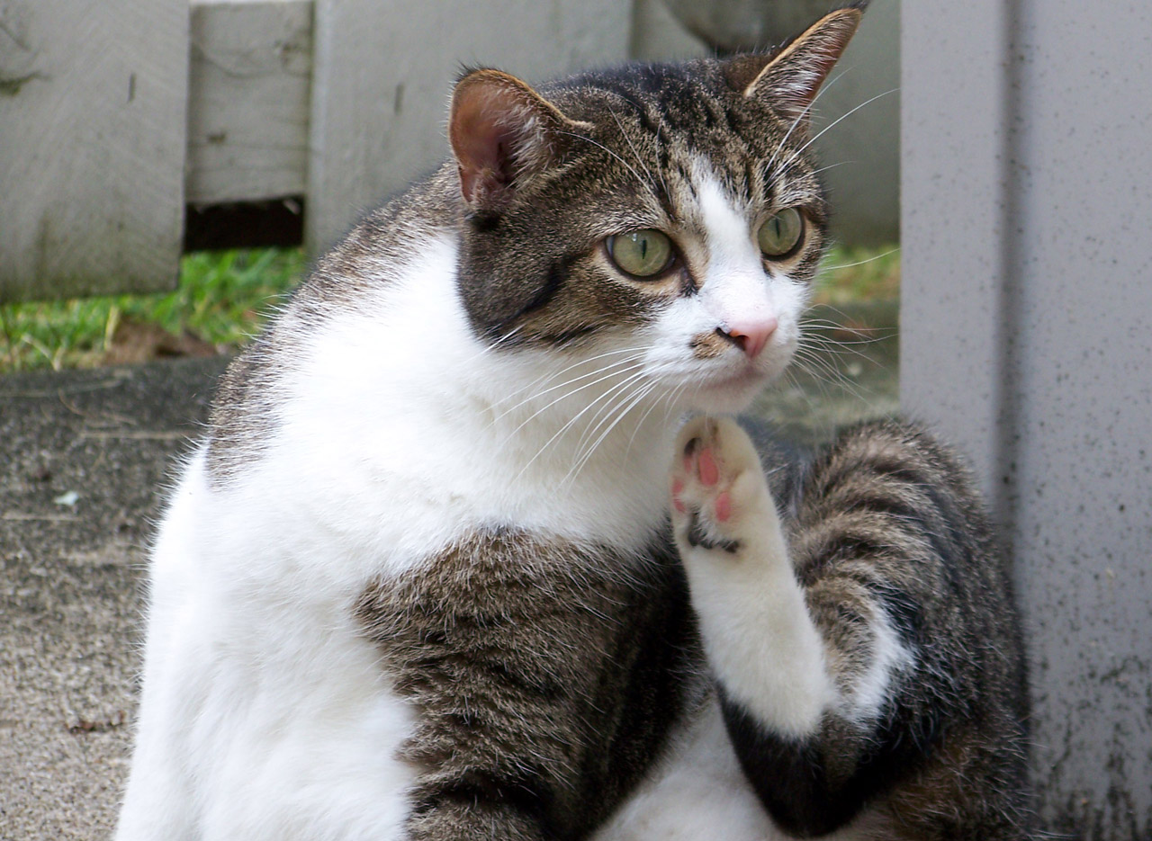

Signs of an Infestation
Many cats are allergic to the saliva of fleas. If you notice your pet scratching a lot, licking itself excessively, or biting at its skin, you should act immediately. These could all be signs of a flea infestation. Open wounds on a cat’s skin, whether self-inflicted or with no obvious cause are also a danger signal.

Dealing with Flea Infestations
There are all sorts of flea-killing pesticide applications available. They can take the form of shampoos, liquids, powders, or even sprays. You may also obtain medications that can be given to the animal orally. If your cat is short haired, you can also comb the fleas out of the cat’s fur with a flea comb. You will need to kill the fleas you remove in this fashion immediately. All you need is a little container with a strong detergent solution, ideally with some rubbing alcohol added.
A cat that is suffering from an infestation of fleas might also be suffering from other infestations. Cats are also susceptible to other parasites, like tapeworms. If a cat is scratching, rubbing itself excessively, or exhibiting unnatural behavior, it is best to take it to the vet for a checkup.
If the cat is injuring itself because of itching or an allergic reaction, your vet can prescribe medications to ease those symptoms. These can be either injected or given to the animal as an oral formula.

Diet Supplements to Repel Fleas
Dietary supplements can be used to reduce the risk of flea infestation. Vitamin B supplements, for example, work very well. Never use any anti-flea product without checking with your vet. Some of these treatments can be dangerous to the animal; others might be ineffective. You should use caution when treating a very young or pregnant cat. Finally, never use anti-flea products meant for dogs on a cat, as they have a much lower tolerance for toxins.

Disinfecting Floors and Surfaces
Ridding your pet of fleas is only the first step to being rid of them permanently. Many fleas, as well as pupae and eggs, will also be infesting your home. You must deal with the entire environment to be rid of them. Failure to do this properly will result in the problem coming back.
There are shampoos, powders, and other products designed to remove insects from carpets, which work for fleas as well. Other insecticidal products are called “growth regulators”. These stop eggs or pupae from growing into adult fleas. If your cat roams outside, your yard will also need treatment.

Living in Harmony with your Pet
The goal of welcoming a cat into your home is to enjoy the companionship and affection they can bring. We have explored some simple ways to care for your cat, to teach it to live in harmony with its, and to live a healthier and happier life. The key to a happy cat – and a happy owner – is learning to understand each other. Ultimately, if you’re genuinely fond of your pet, that’s not something that’s very difficult to achieve.

We hope you enjoyed reading this eBook. If you want to learn more on how to Stop Cats from Spraying by using an easy to follow system click on the link below:

www.CatSprayingNoMore.com

